Jenna Boyes

ID205 DB2

9/11/2024

Design Assignment

# Main Objectives

Currently the information for the Dunedin Ice Hockey Association (DIHA) is spread throughout many systems and is difficult and time consuming to navigate. The objective of this database is to centralise all information into one system and reduce issues with use.

Another objective is to automate sending a list of all fully registered players to NZIHA, as this is required by DIHA to complete each season.

The database information will include data on each person including name, contact and occupation (player, coach, or referee), players’ registration type, coaches’ qualification, referees’ position, teams of players and coaches, leagues of teams and refereed games within leagues. The database will also track awards given to players and/or teams, gear owned by DIHA, and payments made to DIHA.

I have found that collecting info about penalty box and scoring box workers is out of scope. The way DIHA is currently assigning people is working well.

# Use Cases

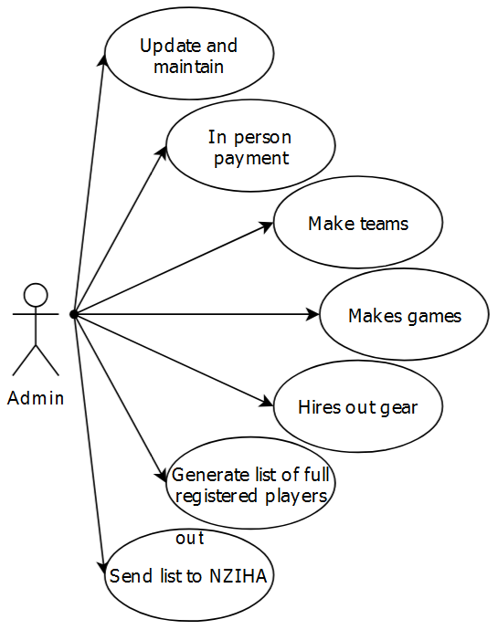

Admin:

* Updates and maintains the database as needed
* Adds the payment to DB if the person has paid in person
* Makes teams based on count of players in each league
* Assigns games their date/time and people involved (teams, refs, etc)
* Tracks who hires what gear and the fee(s)
* Generates a report on all fully registered players
* Sends the report to NZIHA

Player:

- Gives their information (name, contact, etc)  
  
- Pay online for their registrations and hire fees

Coach:

- Assigns themselves to the team(s) they will be coaching  
  
- Assigns players in their team(s) shirt numbers

# Data Model

# Data Dictionary

|  |  |  |
| --- | --- | --- |
| **Person** | | |
| string | name |  |
|  | | |
| **Player** | | |
| date | DOB | date of birth |
| int | shirt_num | number on player shirt |
|  | | |
| **Coach** | | |
| string | qualification |  |
|  | | |
| **Referee** | | |
| string | position | linesman or qualified |
|  | | |
| **Contact** | | |
| string | parent_name | optional name of parent or caregiver |
| string | phone |  |
| string | address | physical address, not mail |
|  | | |
| **Payment** | | |
| string | type | cash or card |
| float | amount |  |
|  | | |
| **Registration** | | |
| string | type | social or full |
|  | | |
| **Team** | | |
| string | name |  |
| string | season |  |

|  |  |  |
| --- | --- | --- |
| **Game** | | |
| date/time | schedule | when game is planned |
| string | winning_team | ID of |
| int | winning_score | score of winning team |
| int | losing_score | score of losing team |
|  | | |
| **League** | | |
| string | name |  |
| string | restriction | u16, open etc |
|  | | |
| **Gear** | | |
| string | item | skates, kneepads etc |
| bool | is_hired | is currently hired or in storage |
| float | fee | cost for hire of season |
|  | | |
| **Award** | | |
| string | name |  |